Answers:
1. Unlocking Approved Hour:
Supervisor Acct = unlock weeks & months
Candidate Acct = request unlocks from supervisor (both week or months)
Signed MVF Unlock: Yes, clear both signatures to be resigned after edits. New form should override previous form to avoid duplicates.

2. Admin Account: info@corbehavioral.com
Director Account: assigned to Amanda Figueiras amanda@corbehavioral.com:
It can wait if we have the unlocking features added.
Yes, all of these features: unlock anything, delete accounts, assign supervisors to candidates, see all candidates.

3. Monthly Verification Form (MVF)
Form Generation: Either account can generate MVF after hours are approved.
Responsible supervisor = primary supervisor.
Signatures: Electronic signatures seem fine. We’ve been signing using the Google signature feature or adding from Apple preview without issue. Ideally, all MVF fields editable/filled out by Fieldwork Pro with in app information, signed in app by both parties and stored in app by both parties with options for download.
NOTE: When filled out Adobe, the MVF will auto calculate Monthly Total and Supervised percentage from other inputs. If all form input fields are editable, this can be overridden. This function works in Docuhub (Google Drive Add on), this function does NOT work in Apple preview.
"Independent" & "Supervised" Hours: Count Supervision activities (group, individual & observation) = “Supervised”. Everything = Independent (Unsupervised). Is that right? YES.

APP GENERATED HOURS TO INPUT IN MVF
- “Unsupervised Hours” (in-app) = Independent Hours
- “Supervised Hours” (in-app) = Supervised Hours
- “Observation” Hour Duration = These fieldwork hours include HH/MM of observation.
- “Monthly Total” (in-app) = Total Fieldwork Hours
- “Supervision Percent” (in-app)= Percent Supervised
See screenshot of in-app equivalents below: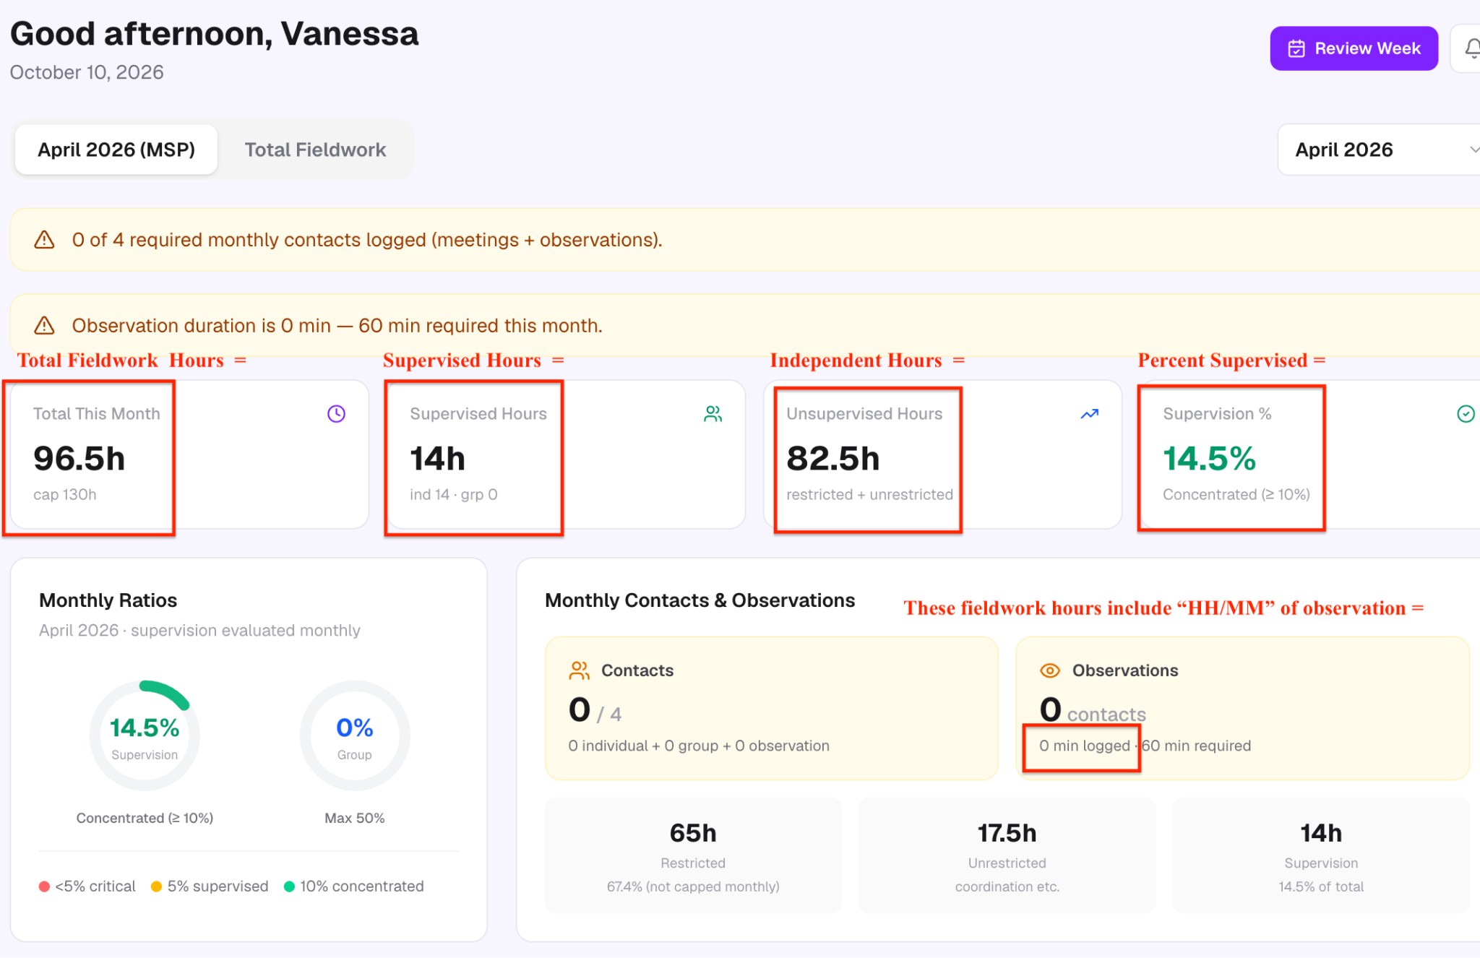.
The form asks for the candidate's fieldwork state and country. Is that the same for every month, or can it change? It could change if they change locations. Not likely, but a dropdown or fill in may be useful.

4. See sample MVF below.


